**Vidyavardhaka College of Engineering**

# An Autonomous Institute affiliated to VTU, Belagavi



## ELECTROMAGNETICS AND WAVE PROPAGATION – 20EC44

## ACTIVITY BASED ASSESMENT

## Report on

**“WIRELESS ELECTRIC TRANSFER”**

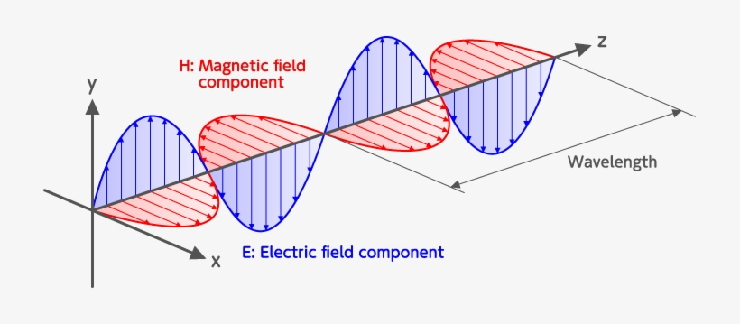

**Submitted by,**

**NAME: MANOJ KUMAR J 4VV20EC087**

**NAME: MANJUNATH B M 4VV20EC083**

**NAME: MAYUR V 4VV20EC089**

**NAME: KARTHIK V S 4VV20EC070**

**Department of Electronics and Communication Engineering**

**Vidyavardhaka College of Engineering, Mysuru - 570002**

**INTRODUCTION**

**Wireless power can be defined as the transmission of electrical energy from a power source to an electrical load without connecting wires. It is reliable, efficient, fast, low maintenance cost, and it can be used for short range or long range. The basic working principle of wireless power transfer is, two objects having similar resonant frequency and in magnetic resonance at powerfully coupled rule tends to exchange the energy, while dissipating relatively little energy to the extraneous off-resonant objects.**

**WORKING PRINCIPLE**

**INDUCTIVE COUPLING:**

**Two conductors are set to be inductively coupled or magnetically coupled when they are configured in a way such that change in current through one wire induces a voltage across the ends of the other wire through electromagnetic induction.**

**RESONANCE INDUCTIVE COUPLING:**

**It is a phenomenon with inductive coupling where the coupling becomes stronger when the secondary side of the loosely coupled coil resonates. Combination of inductive and resonance where resonance makes 2 objects interact very strongly and inductance induces current. Coil provides the inductance and the capacitor is connected parallel to it. Energy will be shifting back and forth between magnetic field surrounding the coil and electric field around the capacitor radiation loss will be negligible.**

**ADVANTAGES AND DISADVANTAGES**

**Advantages of Wireless Electric Transfer are as follows:**

* **There are no wires used**
* **There is no E-waste generated**
* **Need of battery can be eliminated**
* **Efficient energy transfer using Resonance Inductive Coupling**
* **Harmless, if field strength is under safety limits**
* **Maintenance cost is less.**

**Disadvantages of Wireless Electric Transfer are as follows:**

* **Distance constraint**
* **Field strengths must be under safety limits**
* **Initial cost is very high**
* **Tuning is difficult**
* **Non directional**

**APPLICATIONS**

* **Electronic equipment charging**
* **Electric automobile charging for both static and moving**
* **Industrial purposes for harsh environment**
* **Arial vehicles take off**

**EXPERIMENT CONDUCTED BY US**

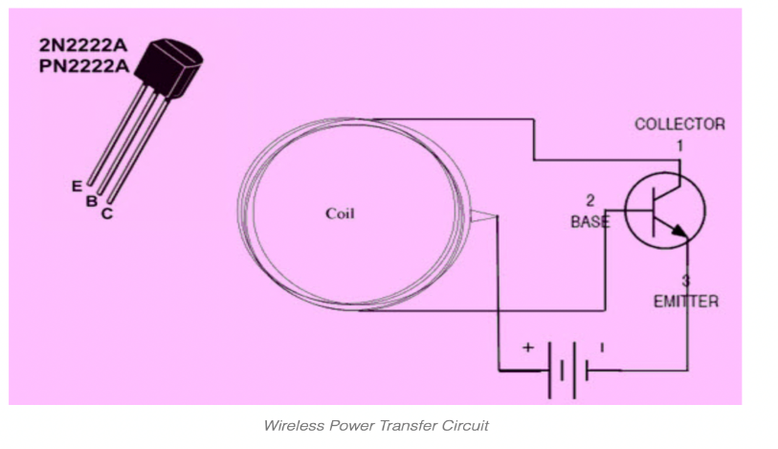

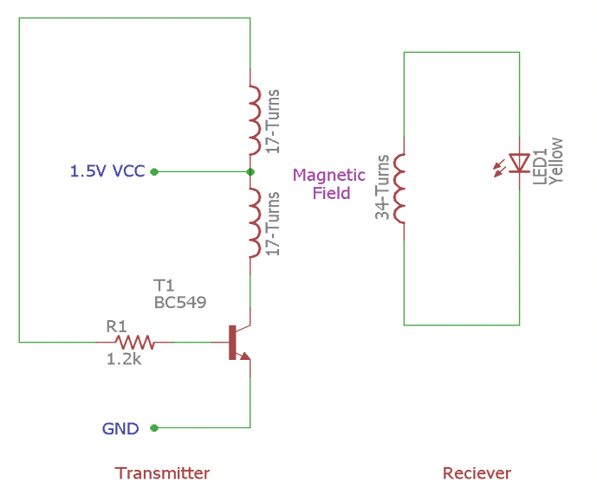

* **Our experimental circuit consists of two parts: Transmitter and Receiver**
* **Here the transistor used is NPN Transistor(2N2222A)**
* **Coil is the crucial part in wireless energy transfer and should be built carefully. In this project, the coils are made using copper wire. Centre tap coil formation is done on the transmitter side. It is used and cylindrical coil wrapper like PVC pipe is required to wind the coil**
* **Our experiment works on inductive power transfer principle**
* **In transmitter section, the Transistor is generating high-frequency AC current across the coil and the coil is generating a magnetic field around it. As the coil is center tapped, the two sides of the coil start to charge up. One side of the coil is connected to the resistor and another side is connected to the collector terminal of NPN transistor. During the charging condition, the base resistor starts to conduct which eventually turns on the transistor. The transistor then discharges the inductor as the emitter is connected with the ground. This charging and discharging of the inductor produce a very high frequency oscillation signal which is further transmitted as a magnetic field**
* **On the receiver side, that magnetic field is transferred into the other coil, and by the Faraday’s law of induction, the receiver coil start producing EMF voltage which is further used to light up the LED.**

**REFERENCES**

* **History TV 18 – Episodes about Tesla**
* **Peter Vaessen, “Wireless Power Transmission”**
* **Shahrzad Jalali Mazlouman. Alireza Mahanfar, Bozena Kaminska, “Mid – Range Wireless Transfer using Inductive Resonance”**
* **“Wireless power Transfer via Strongly Coupled Magnetic Resonances”, Science, June 2007**
* **Random Google search’s**